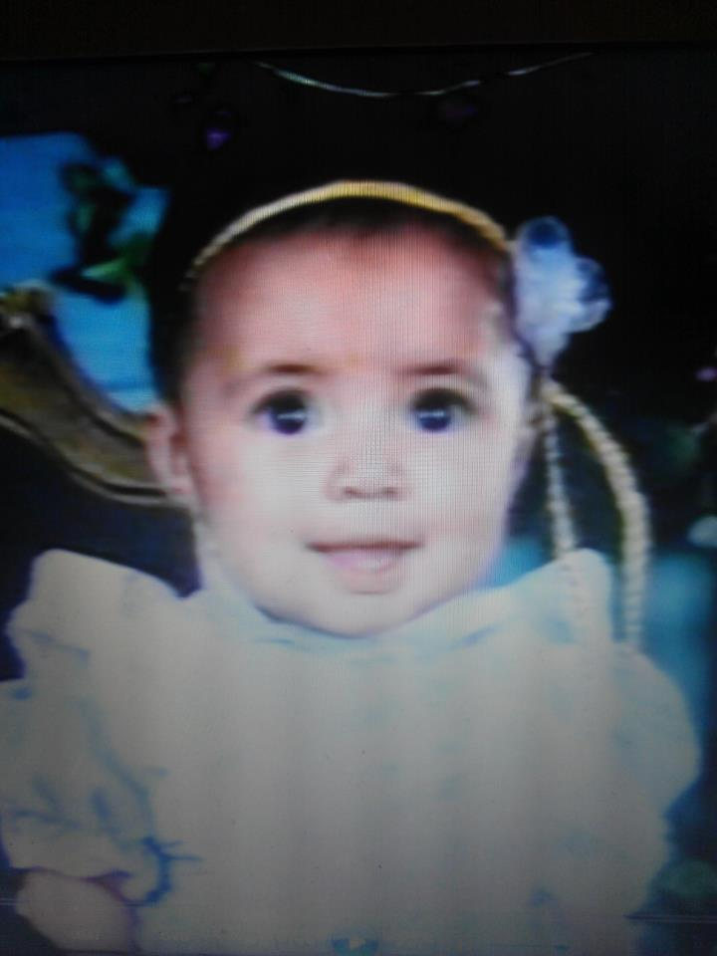
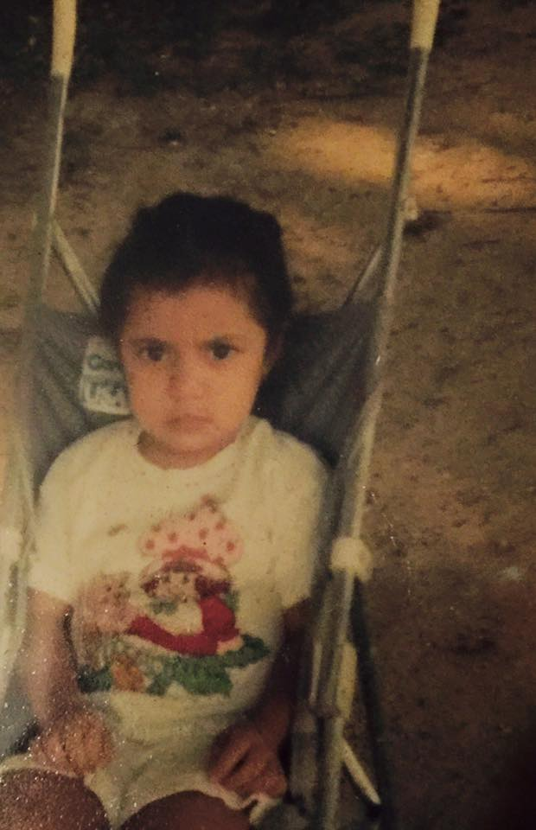
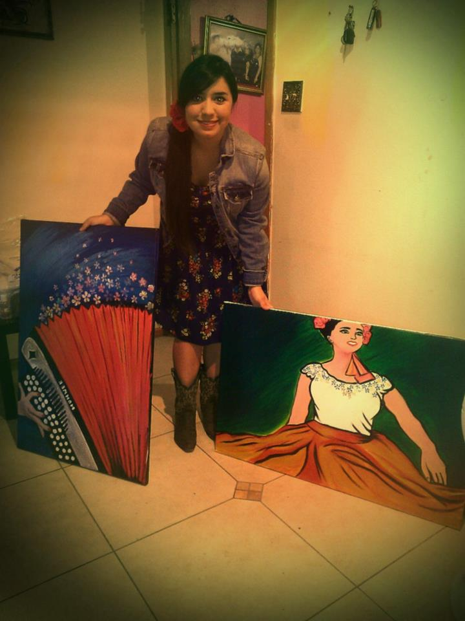
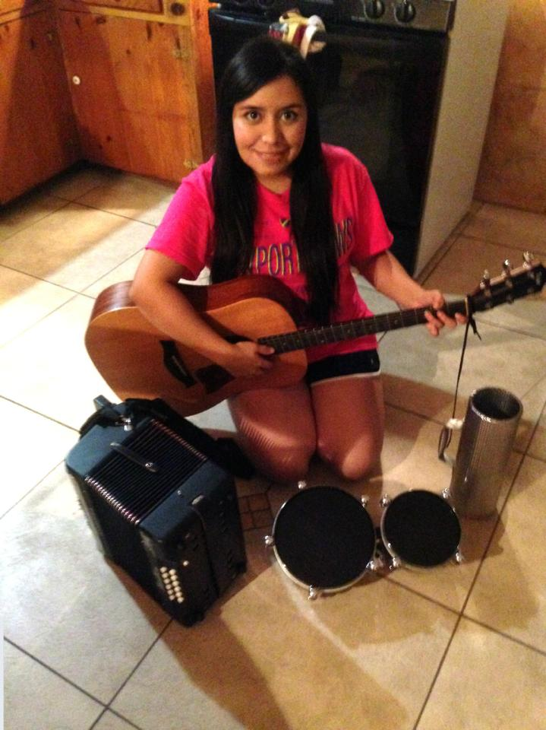
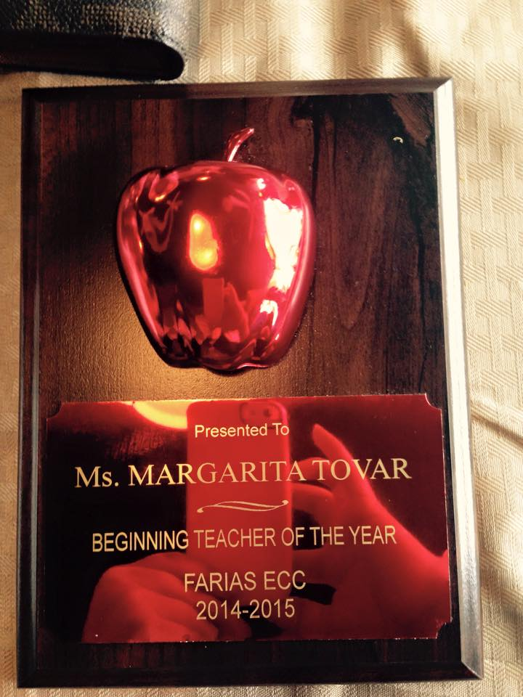
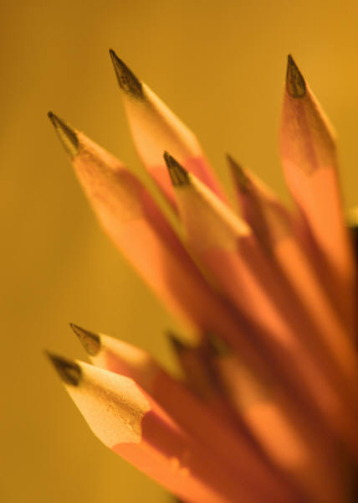
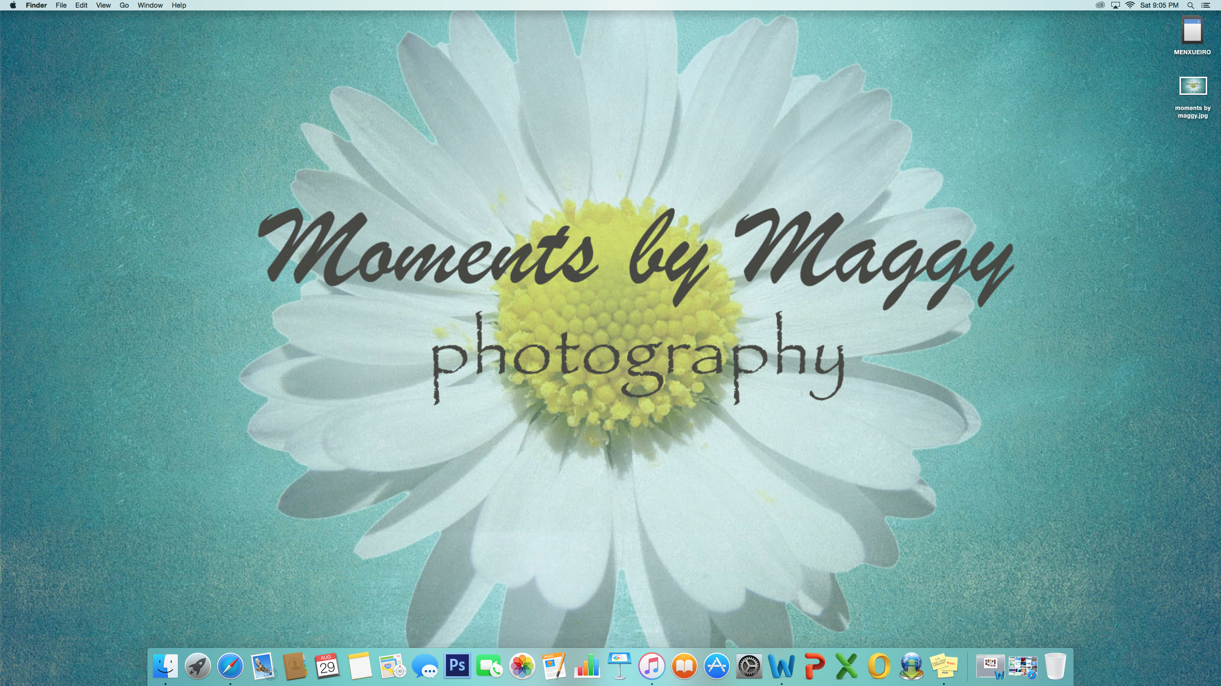
I was born on September 21st, 1990
I was known for always having a frown on my face! That got better over time!
Soccer is one of my passions… GO TIGRES!
But art is my gift!
Music brought my husband and I together!
I love horses and teal!
Last year was my first year teaching. I received the Rookie of the Year award and am looking forward to many more accomplishments as an educator!
_{My Story}

“My Story” Collage

Hello! I hope you’ve enjoyed reading my collage! I’m an avid user of Word but had never created a collage using this program. I preferred creating collages on Publisher since it gives you more freedom to move around images and insert text etcetera. However, the trick to creating a fun collage in Word is wrapping your picture with no boundaries. Below is a description of how I used the eight points found on the Ten Tips for Word (Mac) document.

- Word Art - I placed a SmartArt in the center of my collage with the words “My Story” inside. I knew I wanted my colors to be neutral and simple so I chose white for the accents.
- Object Palette - I used the object palette when placing my screenshot as the background. I wasn’t sure how I was going to incorporate a screenshot into my collage and not have it look like a regular picture. Then as I was staring into my screen I figured I’d just use my Mac background as the background for my collage!
- Screen Shot - I added a grey border to the background on my collage. I tried adding a general border to the whole collage but wasn’t able to make the margins meet outside the actual collage.
- Grouping Tools- I used this tool to group my pictures and my text together. If you select and try to move around my pictures they do not shift from their position unless you decide to ungroup them. I find this very helpful when working on a document with multiple objects.
- Clip Art - I wasn’t sure how I’d use clipart since I had a lot of pictures of everything I needed until I replaced a picture from my classroom with an image of nicely sharpened pencils.
- Insert Images- This collage was possible because of this feature! I gathered 8 images that pretty much summarized my life and inserted them into the document.
- Flow Chart - I was running out of ideas of what other tips to incorporate on my collage so I decided to add a small flow chart to my collage that reads “Love, Music, Art”.
- Insert Text – I wanted to be able to make captions of each picture and was thinking I’d insert an object with text inside, however, it seemed too crammed! (Even more than what it is) I chose to insert text boxes and adjust them into the collage. To make the text easier to read I added transparency to my images and made the text bold.

Ideas

- Teachers can create collages using Texas Guidelines in a workshop. For example, break teachers up into team and assign 3 to 4 guidelines to each team. Then teachers can create a collage that demonstrates these guidelines. If one of the guidelines is “Student can count up to 10 items” the team can draw ten items with numbers on them etc.
- Students can create collages on the first day of school about activities they did this summer.
- Teachers can create a collage about themselves for Meet and Greet/Open House and have it posted on the SmartBoard before the presentation begins.
- Students can take pictures on field trips and then present a collage about their favorite parts of the trip.
- When a class reads a whole chapter book together, instead of breaking up the book by chapters and creating book reports, students can be broken down into groups and each group can create a collage about important events that occurred in their assigned chapters.

